Report Week 11

Achievements:
-Solved issues with multicast packages messing up communication
-Implemented a linked list of unique items on every TCM in order to speed up query processing
and unique ID assignment
-Introduced several debugging modes that highlight specific information at specific points in time,
in this particular case from timer tick 1000 to 1120 (down below)

/* Debugging mode */
#define DEBUG_1 1
#define DEBUG_2 0
#define DEBUG_3 0
#define DEBUG_4 0
#define DEBUG_START 1000
#define DEBUG_END 1120
/* 0 Default information about cores
* DEBUG_1 Enables information about messages received and sent
* DEBUG_2 Debug info on the id distribution algorithm
* DEBUG_3 Information regarding the construction of the linked list dictionary
* DEBUG_4 Shows timer ticks
*/

#define RECORD_IDS 0
#define RECORD_LINKED_LIST_LENGTHS 1
/* 0 record unique ids
* 1 record the length of the linked list
*/

//amount of milliseconds the application runs
uint runtime = 10000;

The new data structure:

In order to speed up the assignment process, I created a linked list in every core's TCM. This list represents an ID-dictionary:

|Entries |ID| |Dictionary |
|--------|--| |Entries| ID |Frequency|Index Start|Index End|
|UK | 1| |-------|----|---------|-----------|---------|
|UK | 1| ---> |UK | 1| 2| 0| 2|
|Germany | 2| |Germany| 2| 1| 2| 3|
|France | 3| |France | 3| 1| 3| 4|

Example:

-The rows here store the precise time of an accident down to the single minute.
That means that the number of possible unique entries is 1440
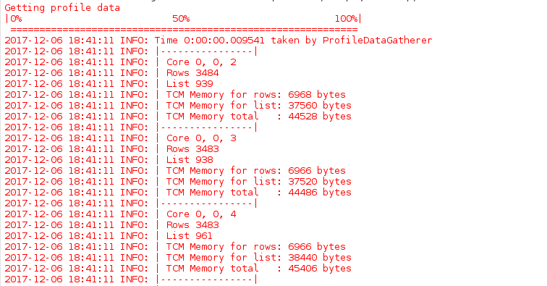

-The rows here store the pdate of an accident. That means that
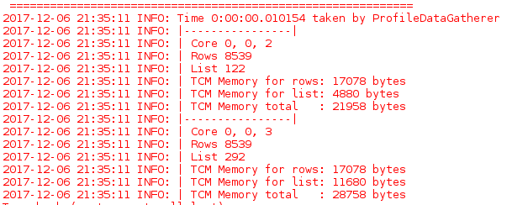
there are 365 possible entries

The purpose of this output is monitoring memory usage in every core's TCM.
A high number of unique elements translates into a large dictionary (linked list), which can lead to memory overload and crashes if not dealt with properly.
One possible way of mitigating this problem could be implementing a data distribution algorithm on the host machine that limits the amount of different entries on every core.

